Window xp
bpm-console-2.0.1

gwt-console-jbpm.war/WEB-INF/lib
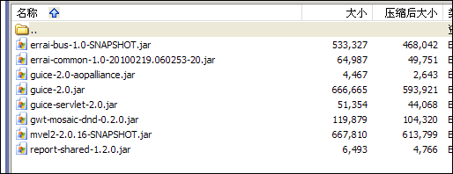

jboss-5.0.0.GA\server\bpm\deploy\jbpm
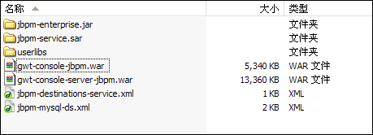

\jboss-5.0.0.GA\server\bpm\deploy\jbpm\jbpm-service.sar
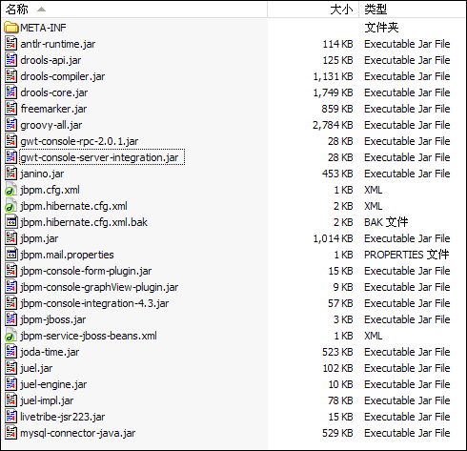

Is these information enough?
Thanks again!

