- Issue:
Too many threads opened but not closed.
I have been observing many threads started especially timer threads and not getting cosed..they are running into thousands in production..please see the screen shot below.

Impact:

Even without many users the number of threads and the base Java Heap memory is increasing even there is no much load on the system.

Analysis:

Verified from forum and Jboss support site, this is a bug which was fixed and they released a jar file for this.
Many recommendations is to upgrade to the latest JBoss 5.1 server which includes lot of fixes and also better memory management etc.
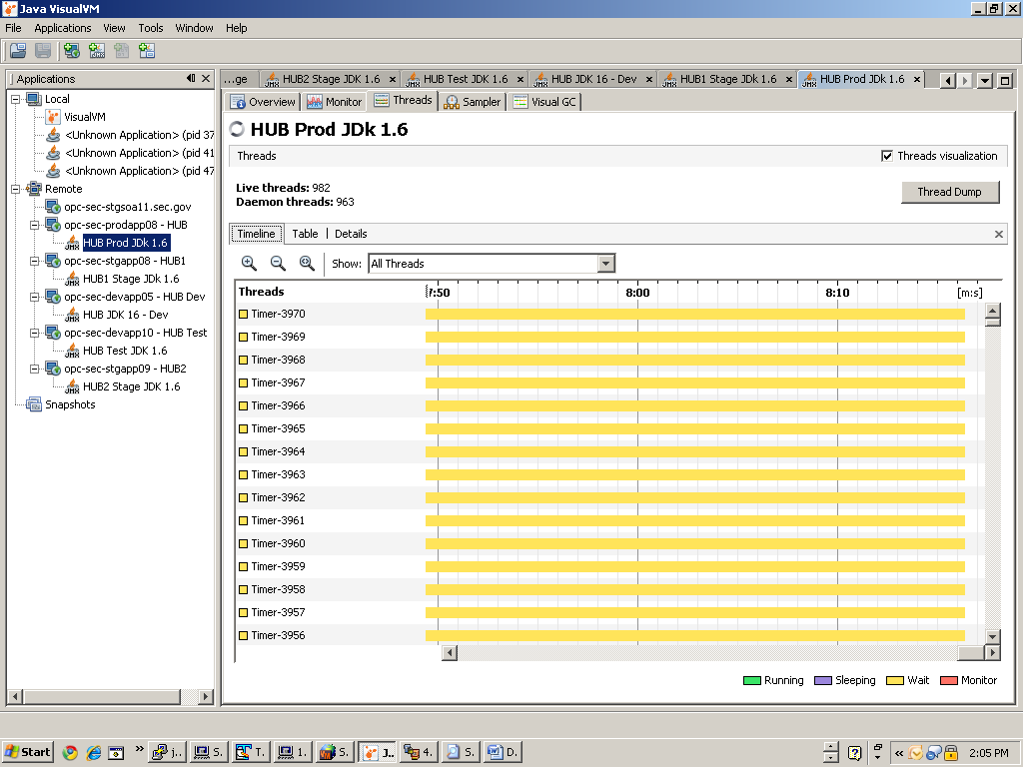

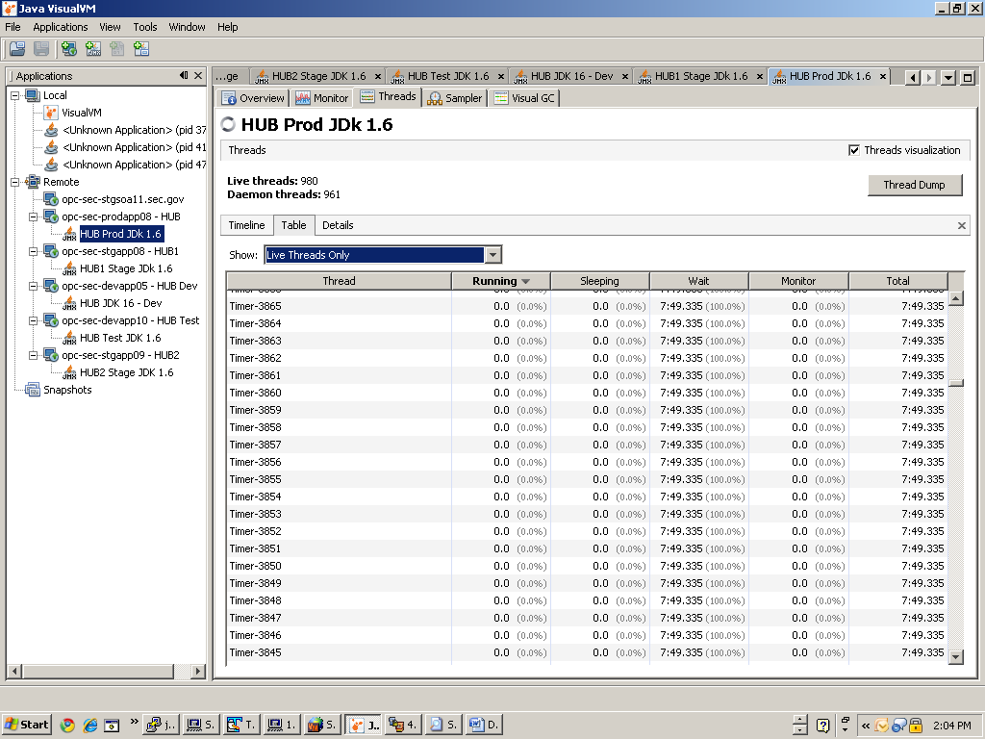

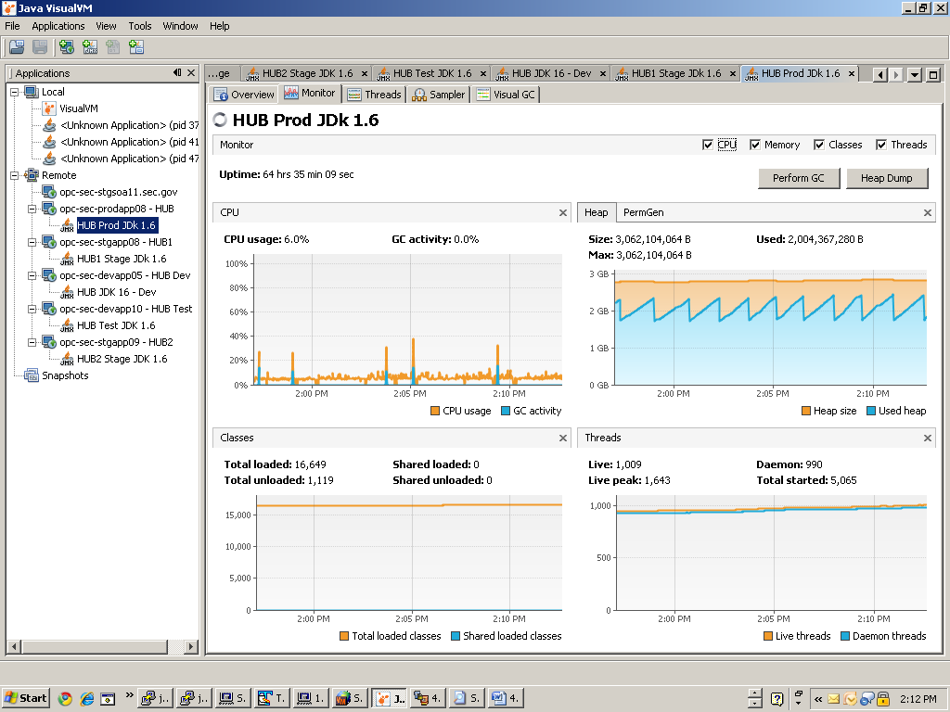
References:
http://community.jboss.org/message/561104
http://www.coderanch.com/t/523248/JBoss/Somany-Timer-Threads-creating-Jboss
https://issues.jboss.org/browse/JBREM-1005
http://www.jboss.com/index.html?module=bb&op=viewtopic&t=138074

