DevelopmentPhase
RTP

development_phase_id | dev_Name
1 | Hit
2 | Lead
3 | Nominee
4 | Lead
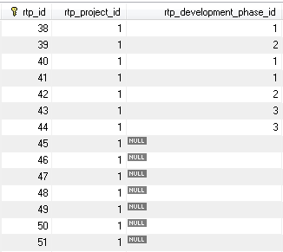

Initially I tried with private int rtp_development_phase_id; as hardcode value so it was saved.
in RTP entity class, later I changed that as many to one relationship and I removed rtp_development_phase_id and used the following in RTP.Java entity class

protected DevelopmentPhase developmentPhase;

@ManyToOne(fetch=FetchType.LAZY)
@Cascade(org.hibernate.annotations.CascadeType.ALL)
@JoinColumn(insertable=true, name="rtp_development_phase_id",
referencedColumnName="development_phase_id")
public DevelopmentPhase getDevelopmentPhase(){
return developmentPhase;
}
public void setDevelopmentPhase(DevelopmentPhase developmentPhase){
this.developmentPhase=developmentPhase;
}

Development phase Table:
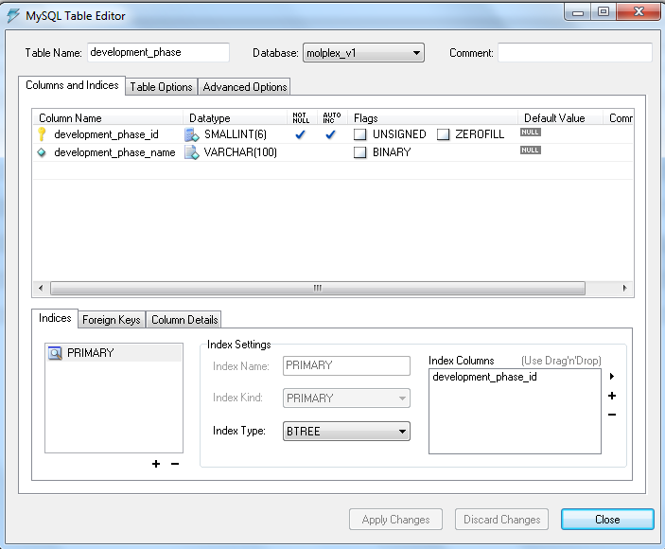

RTP table:
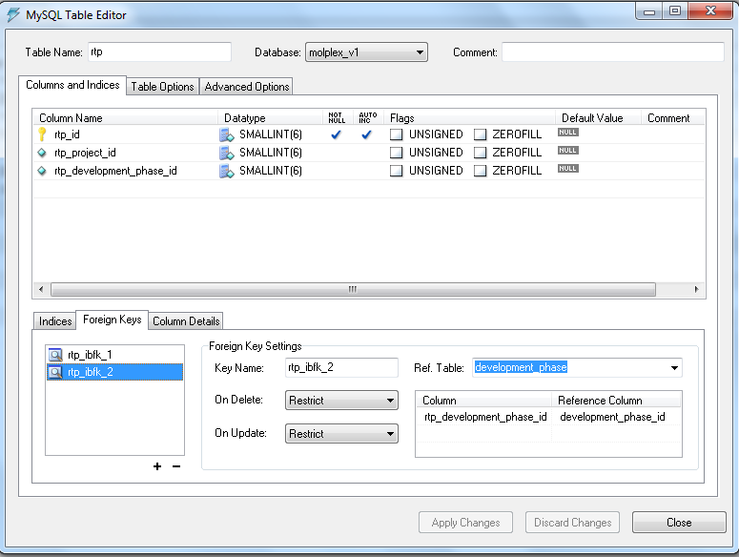

My Screen :
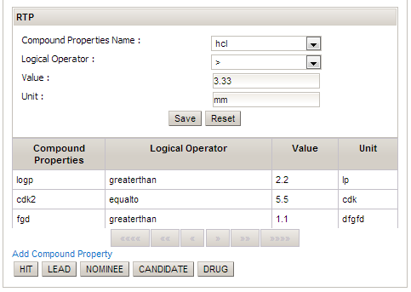

So when I click the save button a record is saved in RTP table with null value in rtp_development_phase_id, I am getting the developmet_phase_id based on clicking the HIT,LEAD,Nominee buttons.

When I click Hit/LEAD/Nominee button , I am calling the actionListner and I am trying to assign like following
public String pageDevelopmentPhaseId(ActionEvent event) {
Object obj=event.getComponent().getAttributes().get("id");
if(null!=obj){
developmentPhase.setDevelopment_phase_name((String)obj);
}
rtp.getDevelopmentPhase().setDevelopment_phase_id(2);
System.out.println("rtp.getDevelopmentPhase");
return "/projects/rtp.xhtml";
}
How can I assign that value to rtp.rtp_development_phase_id

