You are correct Keith, as you said I never seen any where in my console as
14:11:40,789 INFO [org.switchyard] (MSC service thread 1-12) Deploying SwitchYard application

The following are the Steps I did in my Integration of existing Project in to switchyard using ProjectFacet.
Now I am integrating it(SearchBean.java,Search.xhtml,switchyard.xml) in to my seam based GateIn portlet,

The following are the steps I did.
Step:1
Right click on my project and added the Project facet as switchyard
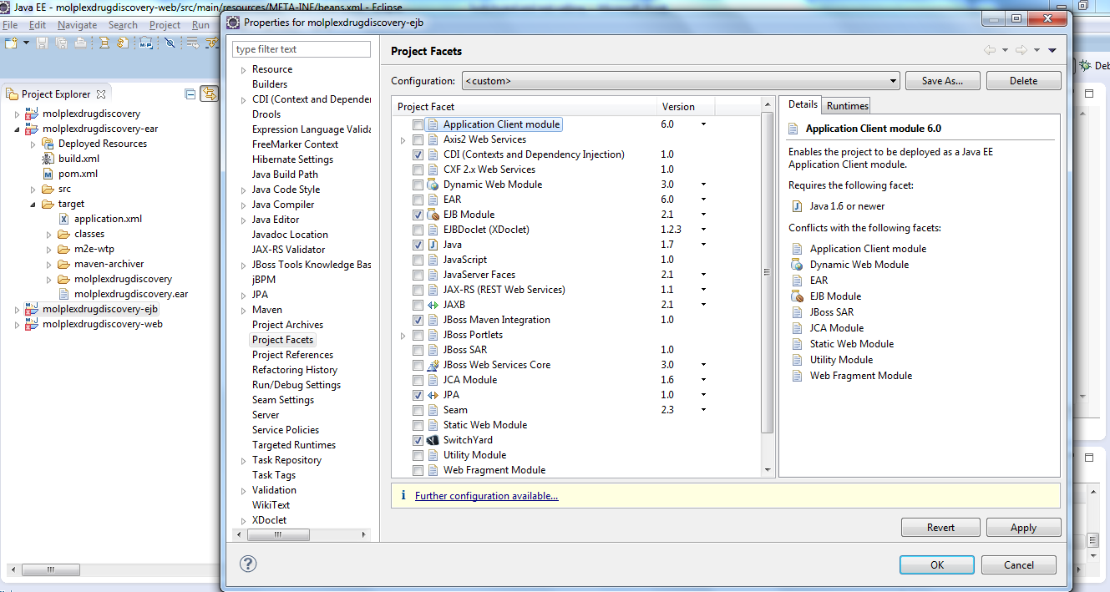

Step:2
I copied the switchyard.xml file from jsf_sample project to myolplexDrugdiscovery project
Under ejb module and edited the
name="molplexdrugdiscovery-ejb" targetNamespace="urn:com.htc.molplex.drugdicovery:molplexdrugdiscovery-ejb:2.3.0.Final"
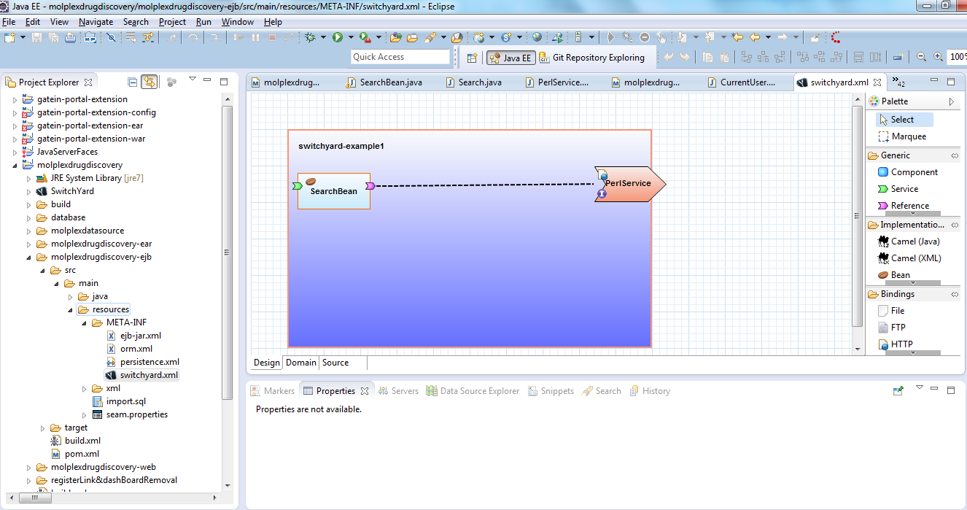

Step:3
I copy and pasted SearchBean.java,Search.java,PerlService.java in to the Ejb Module as follows
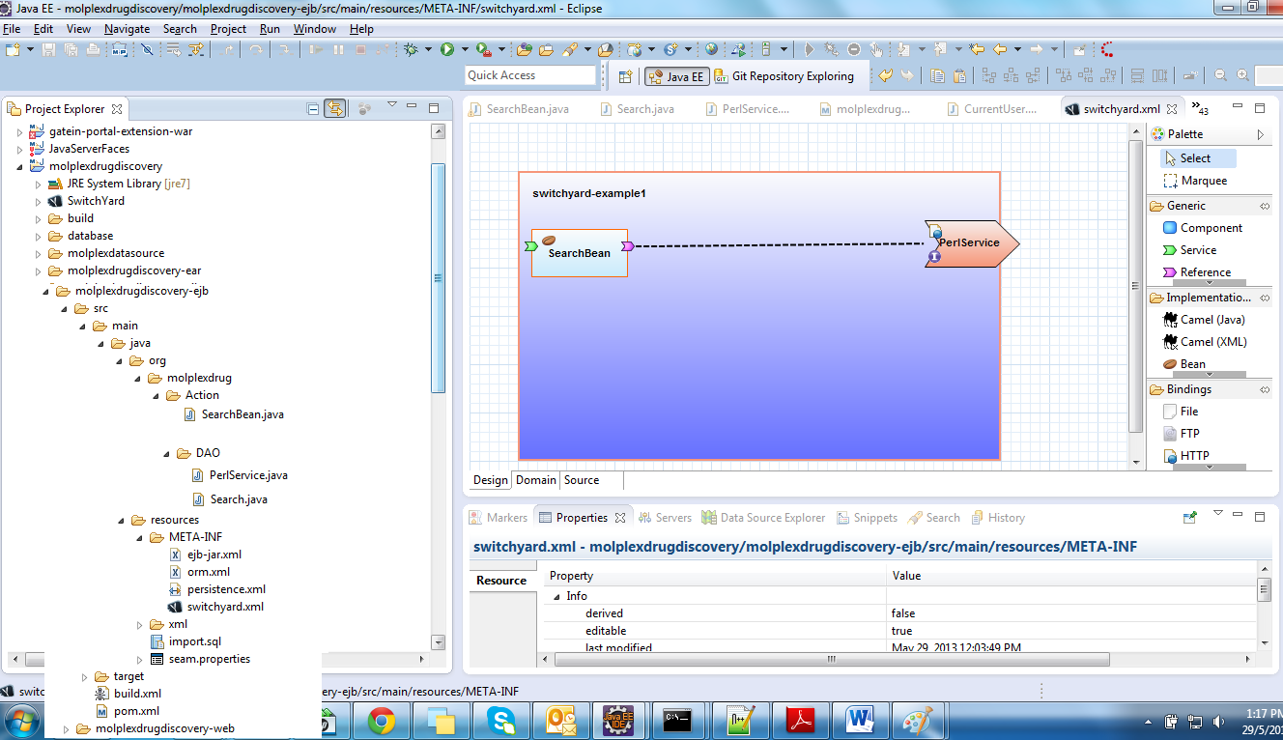

Step:5
And I added the following plugin in my molplexDrugDiscovery ejb module’s Pom.xml,

<build>
<plugins>
<plugin>
<groupId>org.switchyard</groupId>
<artifactId>switchyard-plugin</artifactId>
<version>0.8.0.Final</version>
<configuration>
<scannerClassNames>
<param>org.switchyard.transform.config.model.TransformSwitchYardScanner</param>
</scannerClassNames>
<scanDirectories>
<param>src/main/resources</param>
</scanDirectories>
<outputDirectory>target/switchyard_xml</outputDirectory>
</configuration>
<executions>
<execution>
<goals>
<goal>configure</goal>
</goals>
</execution>
</executions>
</plugin>
<plugin>
<artifactId>maven-war-plugin</artifactId>
<configuration>
<!-- Java EE 6 doesn't require web.xml, Maven needs to catch up! -->
<failOnMissingWebXml>false</failOnMissingWebXml>
<webResources>
<resource>
<directory>target/switchyard_xml</directory>
</resource>
</webResources>
</configuration>
</plugin>
</plugins>
</build>

Step:6
Then when I ran the Gatein Jboss As 7 application Server , I am able to see the Search.xhtml pages as follows.
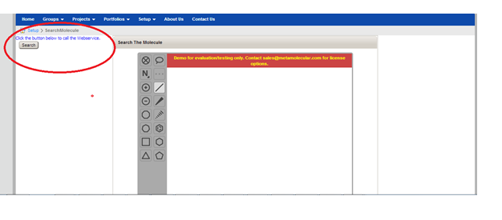

Step:7
After clicking this Search button I am getting Null pointer Exception as follows, might be I am thinking it is not calling the Switchyard.XMl to invoke the EndPoint URL,

This is my overall log ,

