In the Create new bill page for vendor category, if any vendor is selected from the dropdown, then on again clicking on that dropdown no vendor name is showing except the selected one. If that vendor name is deleted then the vendor names are showing in that dropdown.

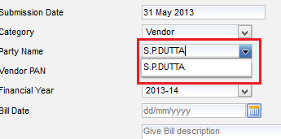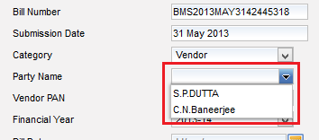

This is the problem.

