Domain at the time of start::
Web Console::

Domain Controller:
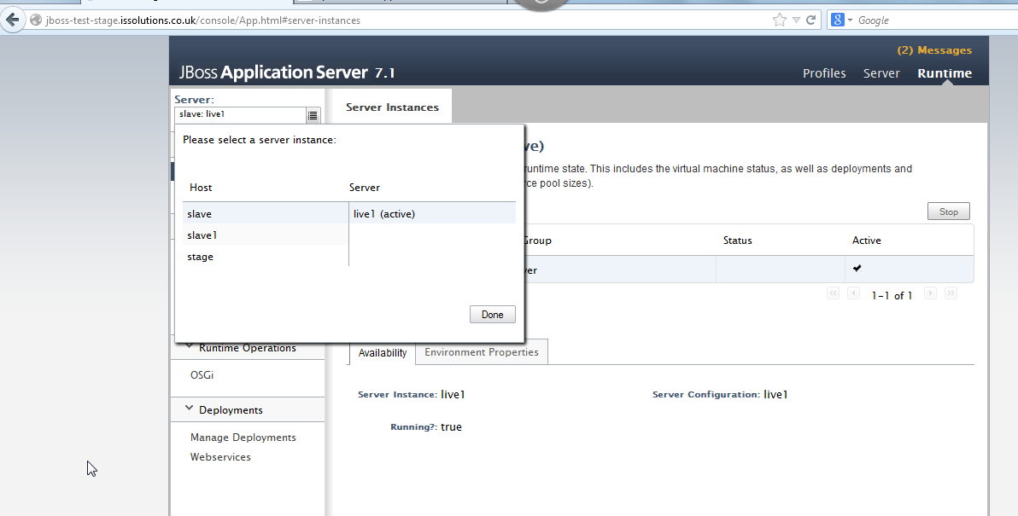

Domain Server:
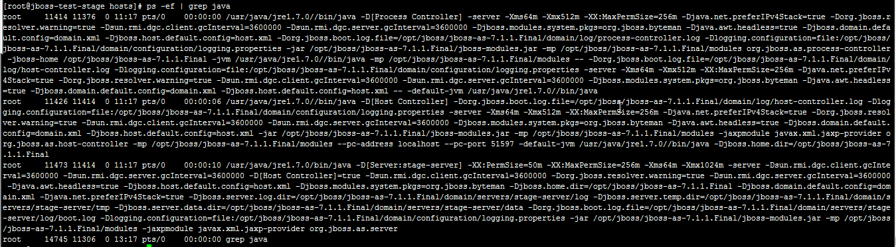

Slave1 or Client 1:
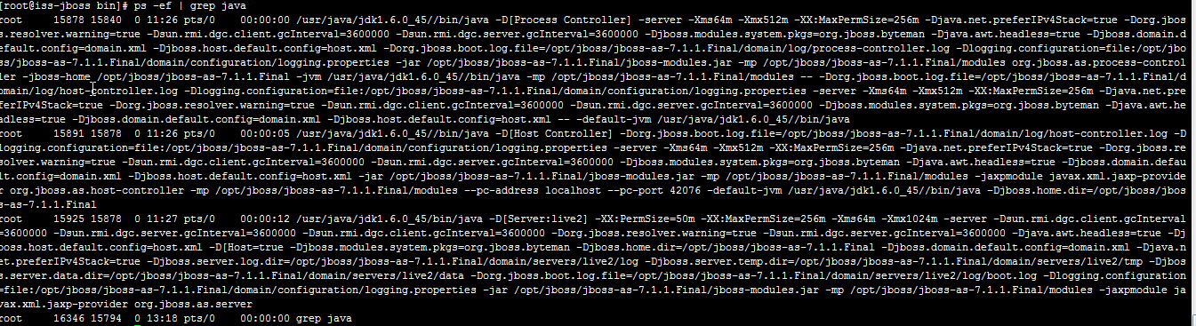

Slave2 or Client 2:
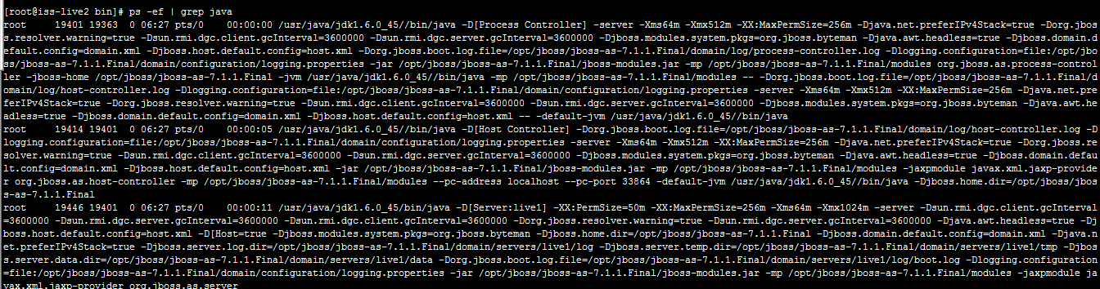

After Two hours::
WEB Interface::
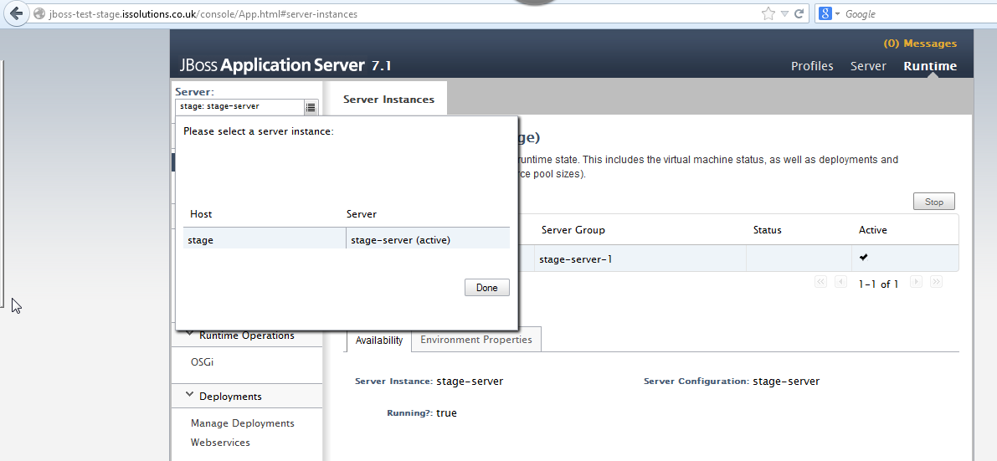

Linux Console::
Domain Controller:

Slave1 or Client 1:

Slave2 or Client 2:

After restarting the clients, clients will again join the domain.

