**Issue Details**

1. **Links - Workaround given at JBPM site**
   1. [Link to workaround](https://developer.jboss.org/thread/241242?start=0&tstart=0)
2. **JBPM version:** 6.0.2.GA BPM Suite
3. **Steps to reproduce after workaround 2**
4. A process with process variable of customType called CusUser (to store user session data) is created and array of custom data type is also there as a process variable; this pattern is used by our solution.  We would send ROL_Approving_DTL as an array of this custom data type as well.
5. Data is initialized via a REST call
6. Data in customTypes goes as null even though data was sent via REST after initializing
7. Only when you try and access the custom data type’s data, following exception occurs:
   1. org.apache.xerces.dom.ElementNSImpl cannot be cast to [Lcom.crl.rol.jbpm.bpmdomain.domain.nd.CusUser;
8. **Applied workaround 2 listed in JBPM suite site:**
   1. [Link to workaround](https://developer.jboss.org/thread/241242?start=0&tstart=0)
      1. Applied workaround – making BPMdomain classes JAR as KJAR by adding kmodule.xml
9. After workaround, data in CusUser[] variable goes as null even though data is initialized via REST call of JBPM 6. Exception is the same. However, another variable with data type CusUser is working fine. It’s the array of custom types that are not working.

**Observation 1**

**Data prior to the workaround (shows that custom objects are getting injected data sent via REST but as null)**

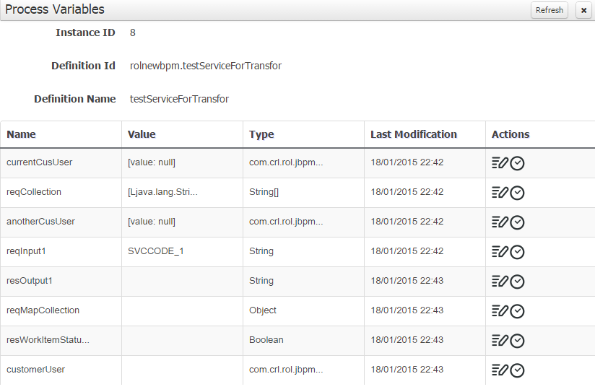

**Observation 2**

1. Was able to start the same process via REST call with array of custom data type and custom data type filled-in and it goes as null in array of custom data type
2. 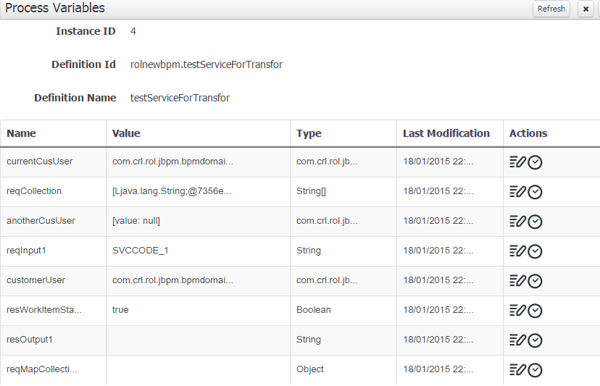
3. Only when you access the variable of type custom data type with array, this error occurs.