Setting up OData connectivity to VDB deployed in Openshift

- Used Docker file create folders and transfer dependent files to the required folder

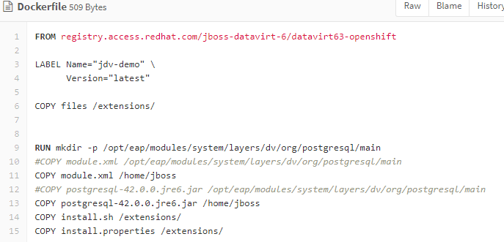
- Install.sh

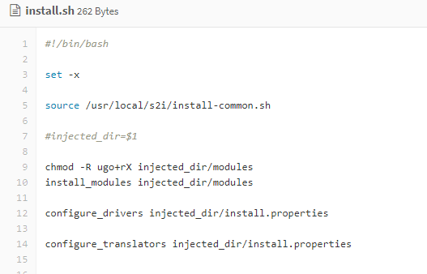

- I am getting following error after making the changes :
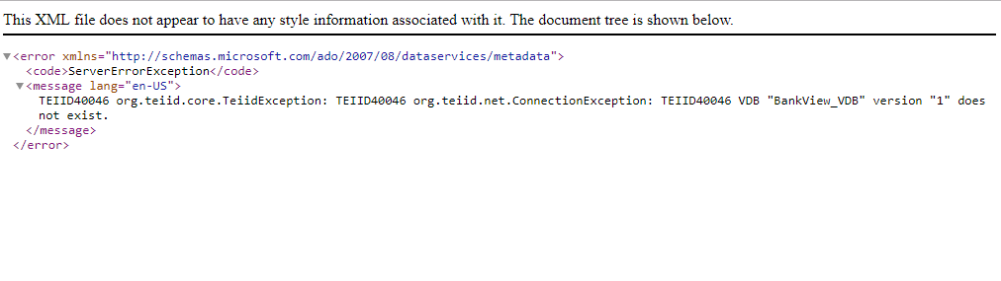
- Please find the log file as attached herewith for your reference

