Issue: Unable query array datatype using Teiid Designer for a MongoDB collection.

MongoDb collection structure as below:
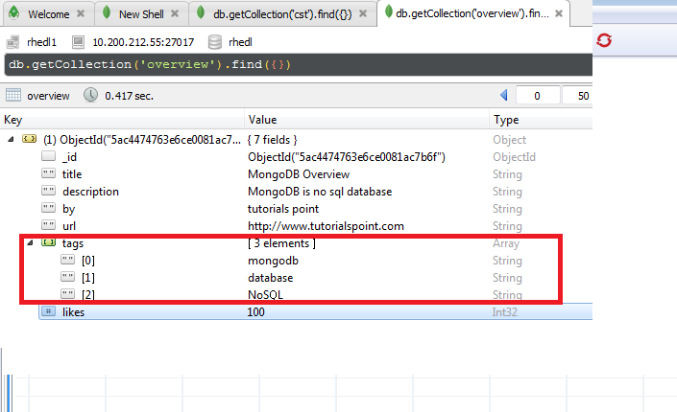
After Importing this collection using Teiid Desginer tags with array datatype get converted to Object
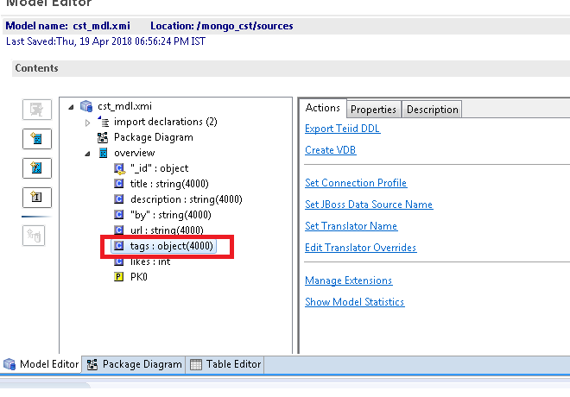
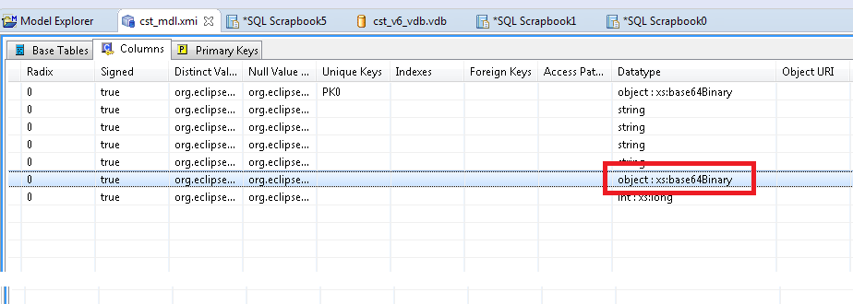
VDB is created and deployed using JBoss Developer Studio and teiid designer.
We are able to query all the columns except tags. I used following query but it failed with error message.
Select array_get(cst_mdl.overview.tags, 1) from overview
Error Message
org.teiid.runtime.client.TeiidClientException: java.lang.RuntimeException: Remote org.teiid.api.exception.query.ExpressionEvaluationException: TEIID30328 Unable to evaluate array_get(cst_mdl.overview.tags, 1): TEIID30384 Error while evaluating function array_get

