Issue – Unable to integrate PostgreSQL and MongoDB view through JDV 6.3
Steps followed are as below:
Step -1 Create view for MongoDB collection
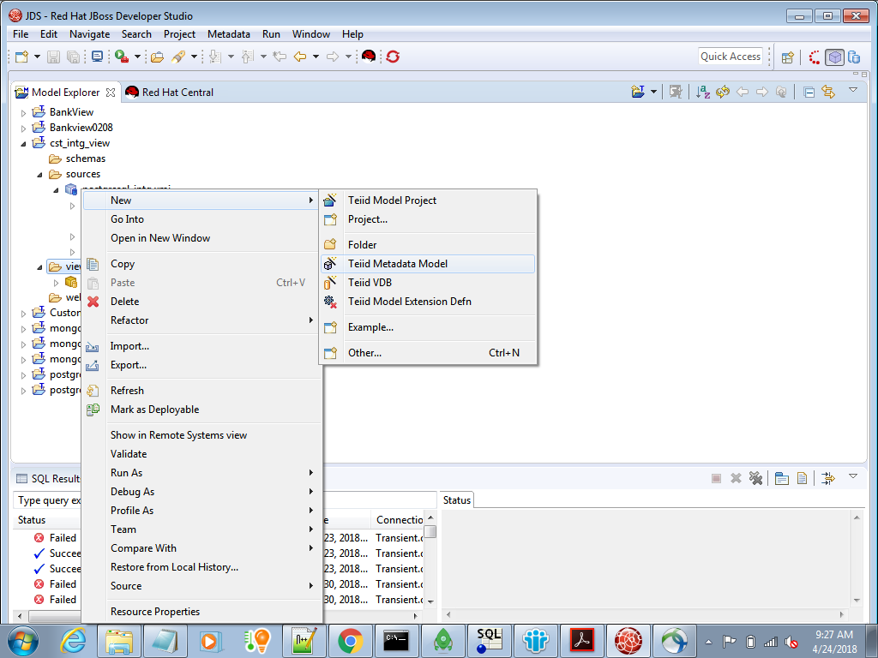

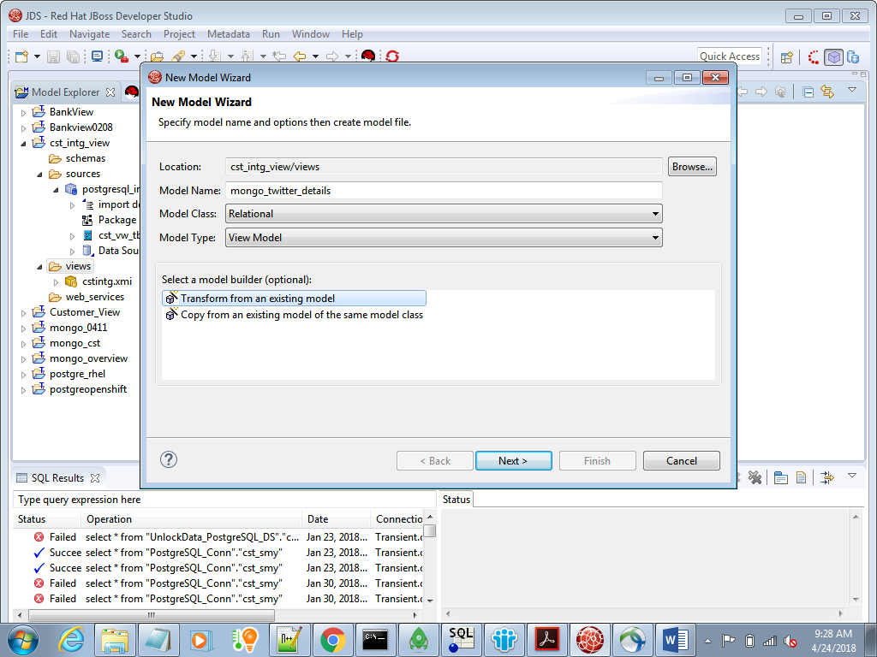
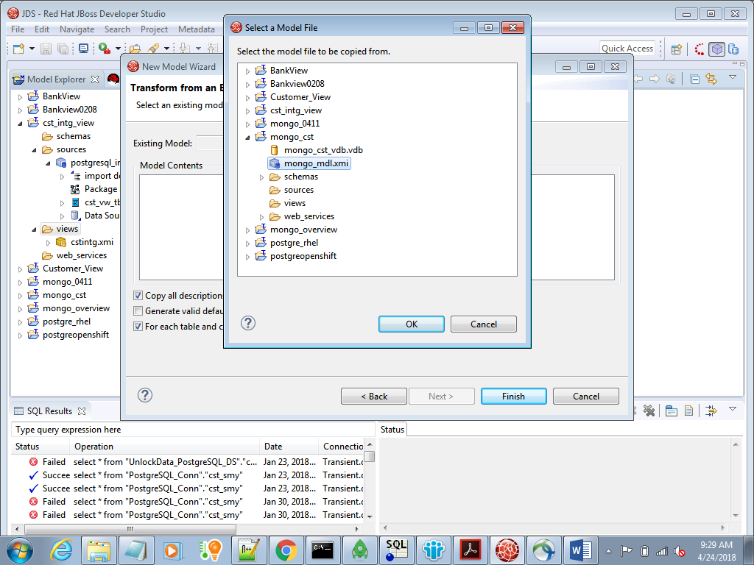
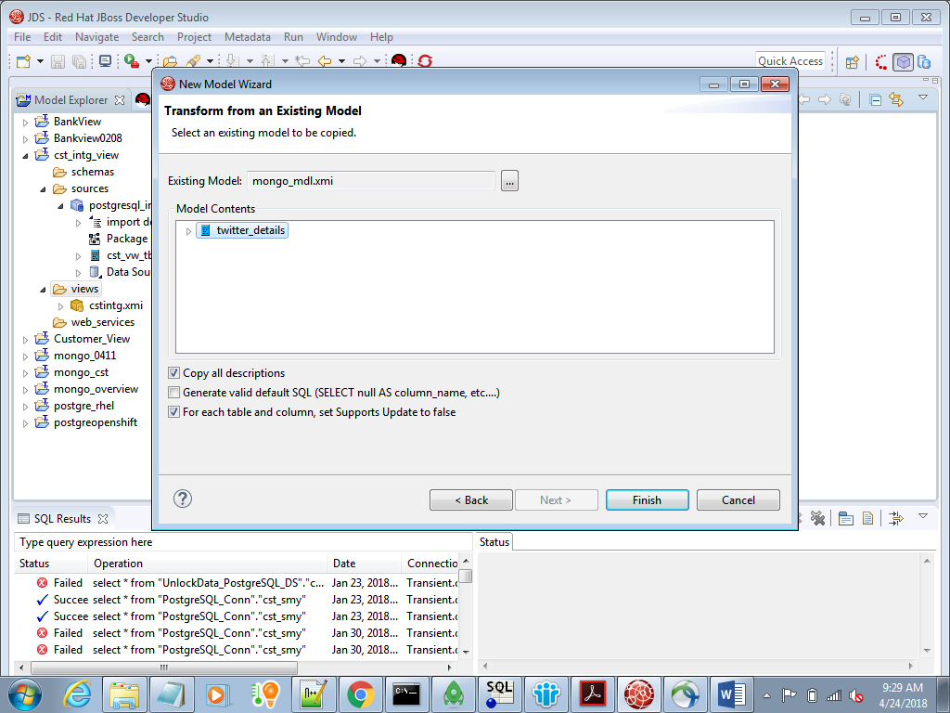
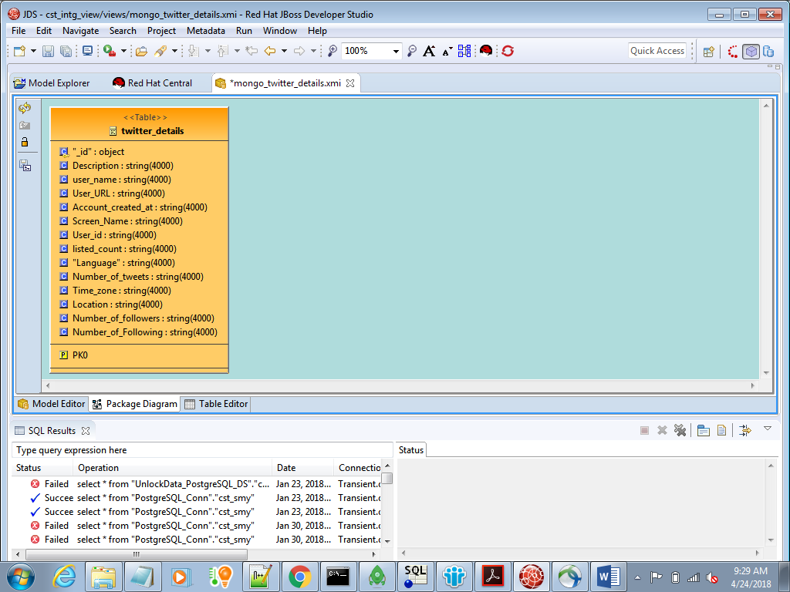

Step-2 Preview data for MongoDB view
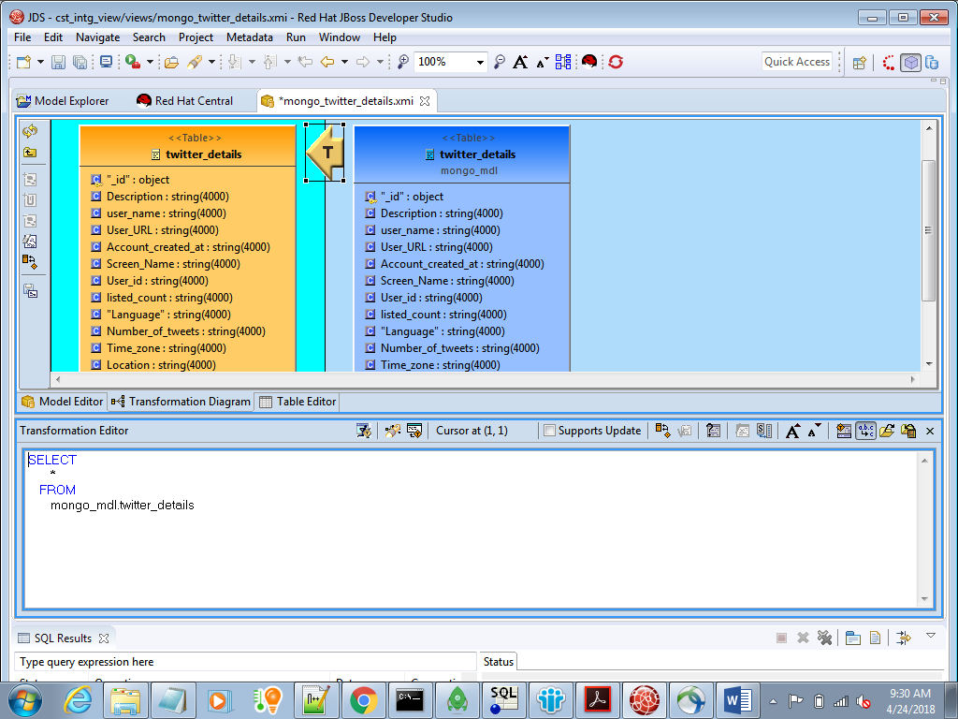
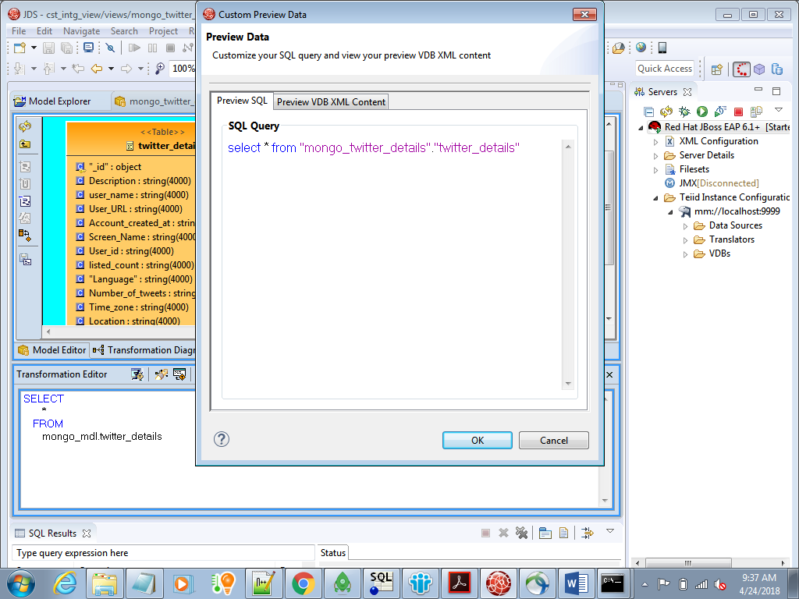
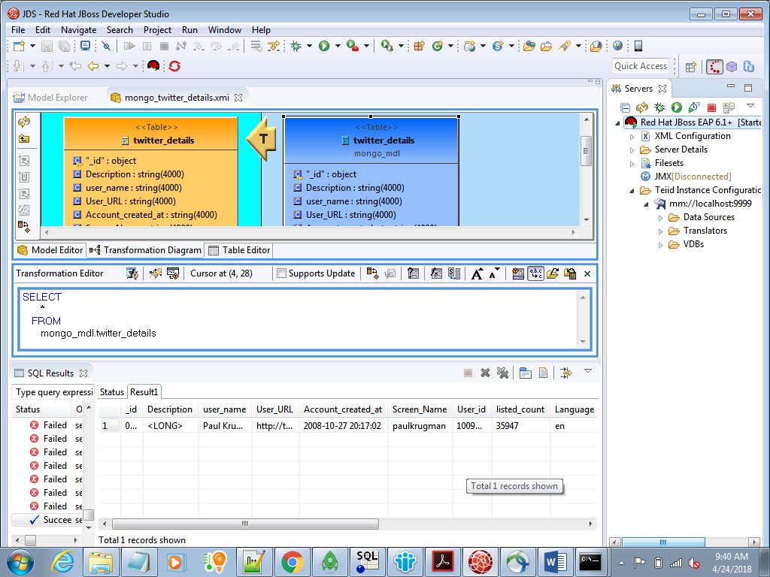

Step -3 Created View for PostgreSQL table and we can preview the data
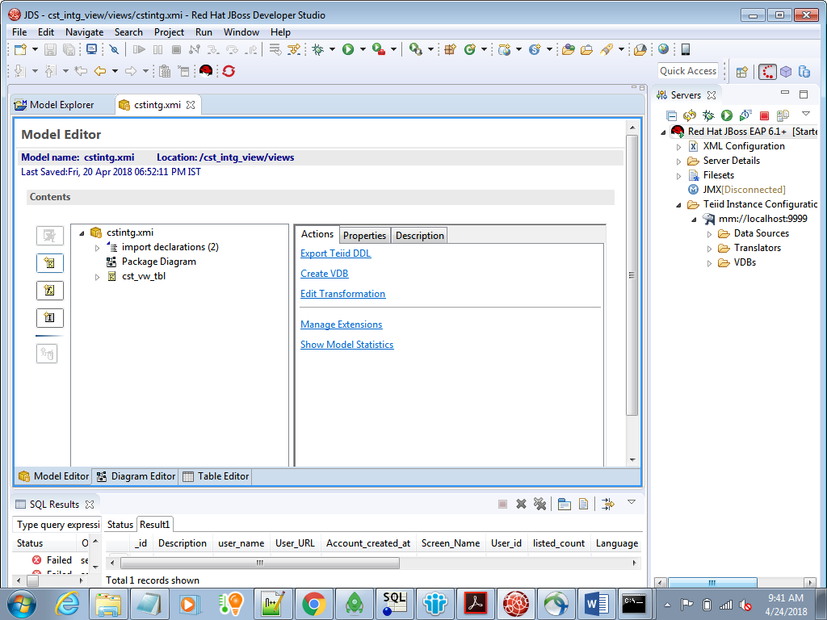

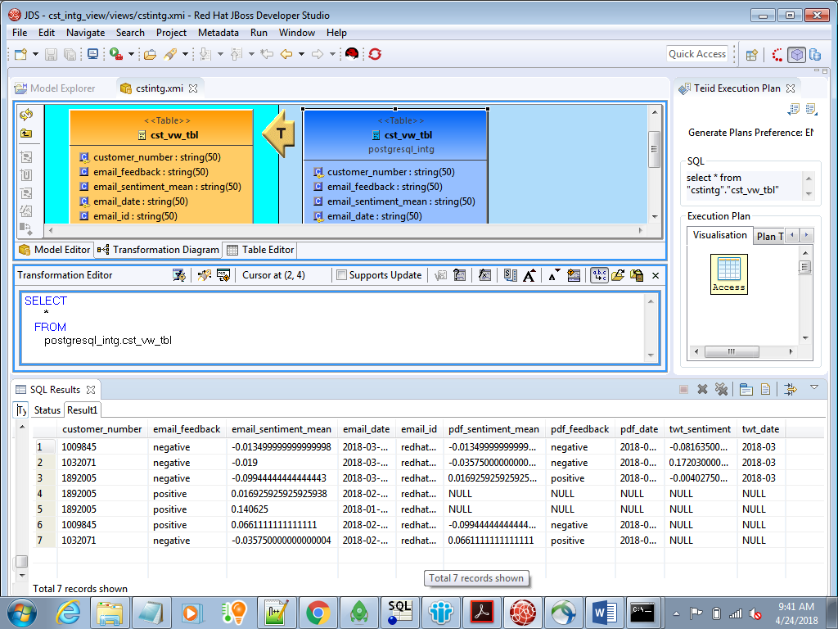

Step4 – Drag and Drop MongoDB view on the below panel to see integrated data of PostgreSQL and MongoDB
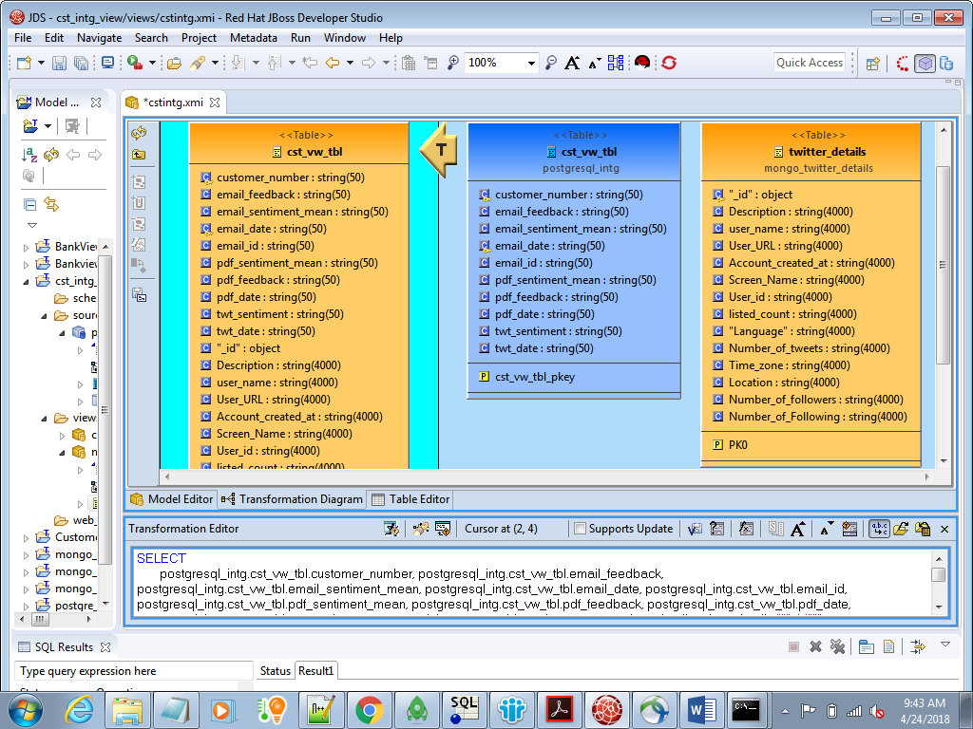
Default query:

SELECT
postgresql_intg.cst_vw_tbl.customer_number, postgresql_intg.cst_vw_tbl.email_feedback, postgresql_intg.cst_vw_tbl.email_sentiment_mean, postgresql_intg.cst_vw_tbl.email_date, postgresql_intg.cst_vw_tbl.email_id, postgresql_intg.cst_vw_tbl.pdf_sentiment_mean, postgresql_intg.cst_vw_tbl.pdf_feedback, postgresql_intg.cst_vw_tbl.pdf_date, postgresql_intg.cst_vw_tbl.twt_sentiment, postgresql_intg.cst_vw_tbl.twt_date, mongo_twitter_details.twitter_details."""_id""", mongo_twitter_details.twitter_details.Description, mongo_twitter_details.twitter_details.user_name, mongo_twitter_details.twitter_details.User_URL, mongo_twitter_details.twitter_details.Account_created_at, mongo_twitter_details.twitter_details.Screen_Name, mongo_twitter_details.twitter_details.User_id, mongo_twitter_details.twitter_details.listed_count, mongo_twitter_details.twitter_details."""Language""", mongo_twitter_details.twitter_details.Number_of_tweets, mongo_twitter_details.twitter_details.Time_zone, mongo_twitter_details.twitter_details.Location, mongo_twitter_details.twitter_details.Number_of_followers, mongo_twitter_details.twitter_details.Number_of_Following
FROM
postgresql_intg.cst_vw_tbl, mongo_twitter_details.twitter_details
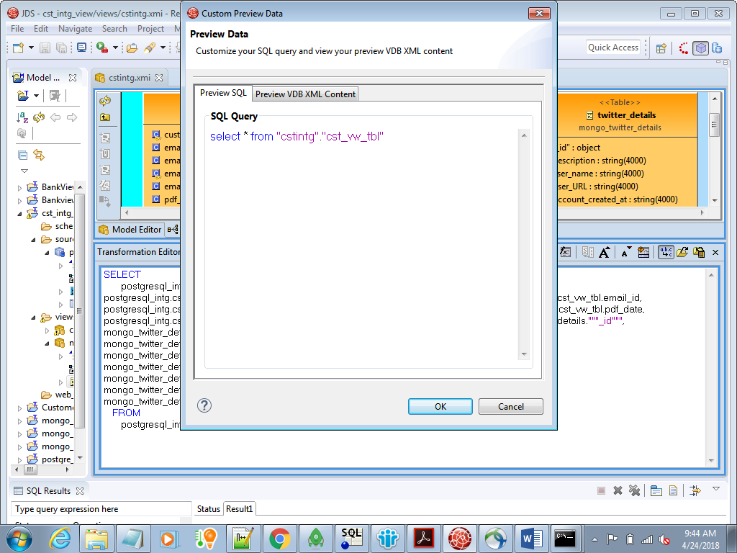
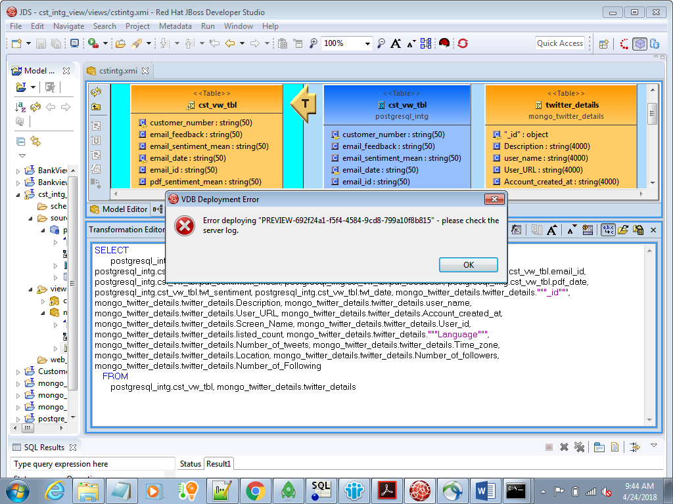
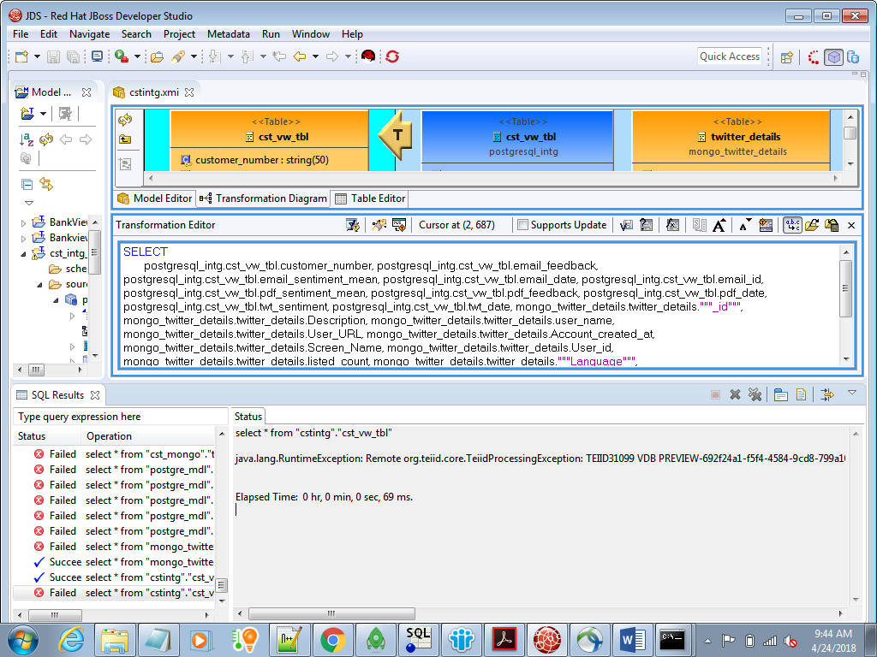
select * from "cstintg"."cst_vw_tbl"
Error Message :
java.lang.RuntimeException: Remote org.teiid.core.TeiidProcessingException: TEIID31099 VDB PREVIEW-692f24a1-f5f4-4584-9cd8-799a10f8b815.1[cstintg{}, postgresql_intg{postgresql_intg=postgresql_intg, postgresql, java:/postgresql_intg}, mongo_mdl{mongo_mdl=mongo_mdl, mongodb, java:/mongo_twitter}, mongo_twitter_details{}] is not active, but FAILED. If loading you can resubmit your query after loading has completed or after the errors have been corrected.
Manually changed query with Inner Join:
SELECT
postgresql_intg.cst_vw_tbl.customer_number, postgresql_intg.cst_vw_tbl.email_feedback, postgresql_intg.cst_vw_tbl.email_sentiment_mean, postgresql_intg.cst_vw_tbl.email_date, postgresql_intg.cst_vw_tbl.email_id, postgresql_intg.cst_vw_tbl.pdf_sentiment_mean, postgresql_intg.cst_vw_tbl.pdf_feedback, postgresql_intg.cst_vw_tbl.pdf_date, postgresql_intg.cst_vw_tbl.twt_sentiment, postgresql_intg.cst_vw_tbl.twt_date, mongo_twitter_details.twitter_details."""_id""", mongo_twitter_details.twitter_details.Description, mongo_twitter_details.twitter_details.user_name, mongo_twitter_details.twitter_details.User_URL, mongo_twitter_details.twitter_details.Account_created_at, mongo_twitter_details.twitter_details.Screen_Name, mongo_twitter_details.twitter_details.User_id, mongo_twitter_details.twitter_details.listed_count, mongo_twitter_details.twitter_details."""Language""", mongo_twitter_details.twitter_details.Number_of_tweets, mongo_twitter_details.twitter_details.Time_zone, mongo_twitter_details.twitter_details.Location, mongo_twitter_details.twitter_details.Number_of_followers, mongo_twitter_details.twitter_details.Number_of_Following
FROM
postgresql_intg.cst_vw_tbl INNER JOIN mongo_twitter_details.twitter_details ON postgresql_intg.cst_vw_tbl.customer_number= mongo_twitter_details.twitter_details.User_id
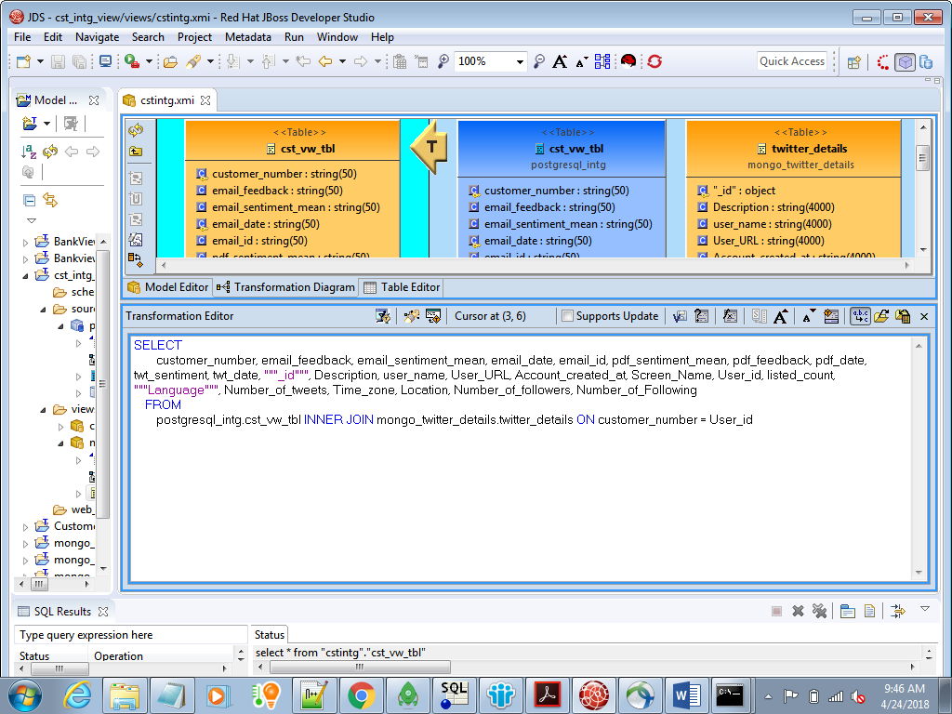
Query got changed automatically as below :
SELECT
customer_number, email_feedback, email_sentiment_mean, email_date, email_id, pdf_sentiment_mean, pdf_feedback, pdf_date, twt_sentiment, twt_date, """_id""", Description, user_name, User_URL, Account_created_at, Screen_Name, User_id, listed_count, """Language""", Number_of_tweets, Time_zone, Location, Number_of_followers, Number_of_Following
FROM
postgresql_intg.cst_vw_tbl INNER JOIN mongo_twitter_details.twitter_details ON customer_number = User_id
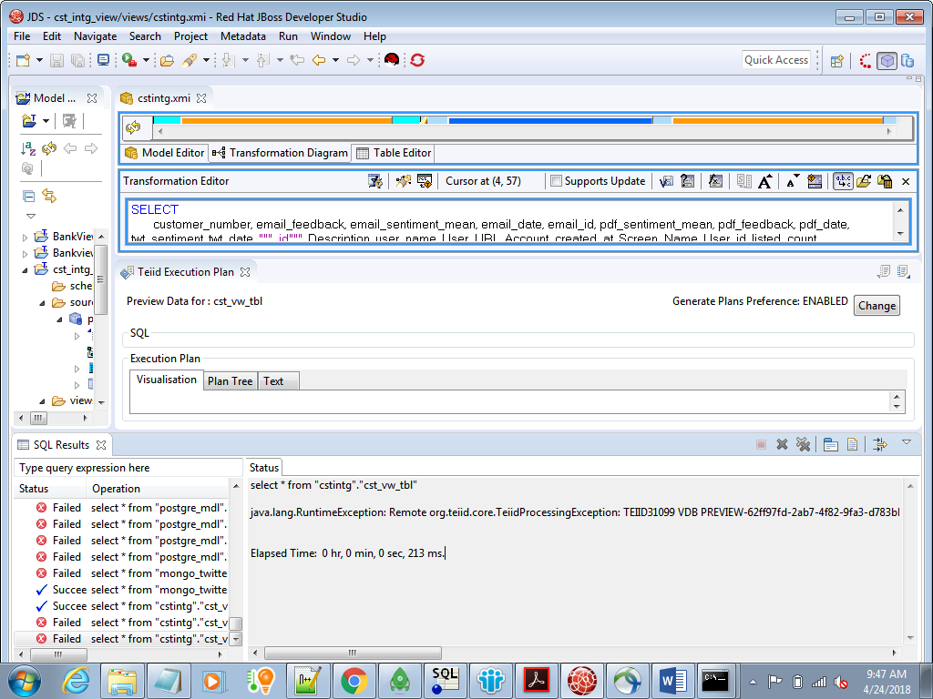
Error Message
java.lang.RuntimeException: Remote org.teiid.core.TeiidProcessingException: TEIID31099 VDB PREVIEW-62ff97fd-2ab7-4f82-9fa3-d783bb8f2765.1[cstintg{}, postgresql_intg{postgresql_intg=postgresql_intg, postgresql, java:/postgresql_intg}, mongo_mdl{mongo_mdl=mongo_mdl, mongodb, java:/mongo_twitter}, mongo_twitter_details{}] is not active, but FAILED. If loading you can resubmit your query after loading has completed or after the errors have been corrected.

