Setting up OData connectivity to VDB deployed in Openshift

- Created VDB for cst_smy table
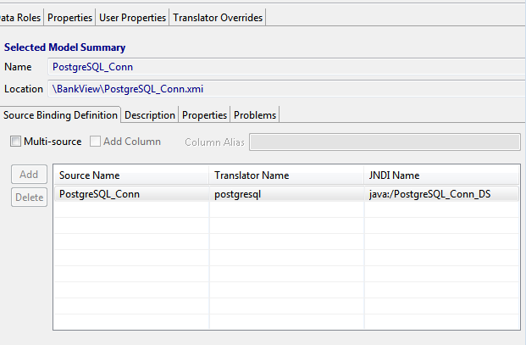
- Installed EAP Server in Local Machines
- Copy PostgreSQL driver and module.xml to modules/system/layers/dv/org/postgresql/main
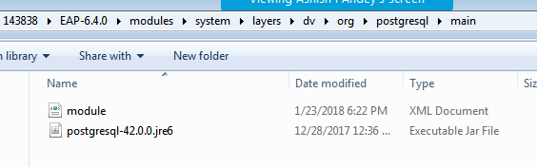
- Restart local EAP server by running bin/standalone.sh
- Add PostgreSQL driver
/subsystem=datasources/jdbc-driver=postgresql:add(driver-name=postgresql,driver-module-name=org.postgresql,driver-class-name=org.postgresql.Driver,driver-xa-datasource-class-name=org.postgresql.xa.PGXADataSource)

- Add PostgreSQL Datasource and enable the Data Source

data-source add --name=PostgreSQL_Conn --jndi-name=java:/PostgreSQL_Conn_DS --connection-url=jdbc:postgresql://xx.xxx.xx.xx:32512/postgres --driver-name=postgresql --user-name=<username> --password=<pwd>

- Enable the Data Source

data-source enable --name=PostgreSQL_Conn

- Check the metadata through OData using below URL
http://localhost:8080/odata/BankView_VDB/$metadata
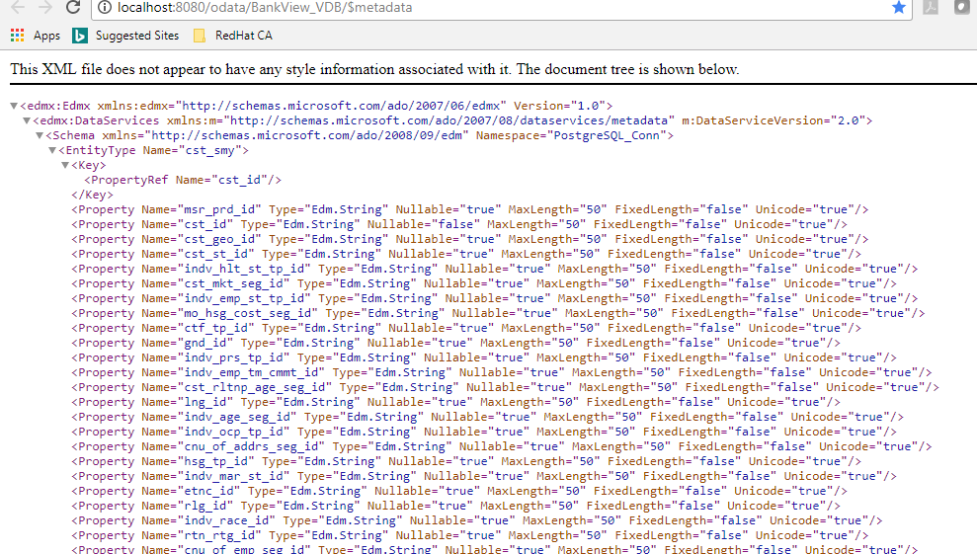

- Check the data through OData using below URL
http://localhost:8080/odata/BankView_VDB/PostgreSQL_Conn.cst_smy?$format=json
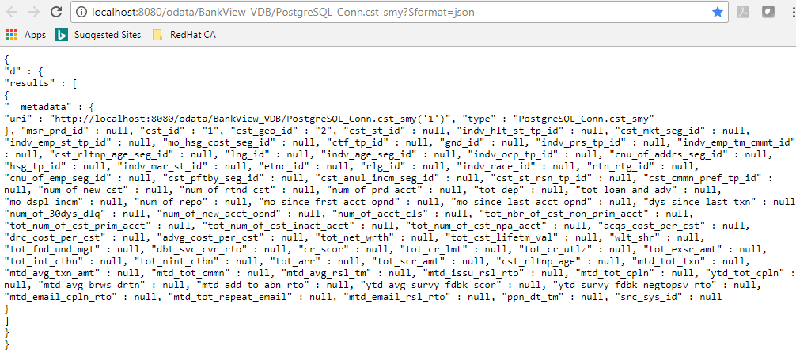
- We are facing issue while accessing VDB deployed on Openshift Pod through OData.
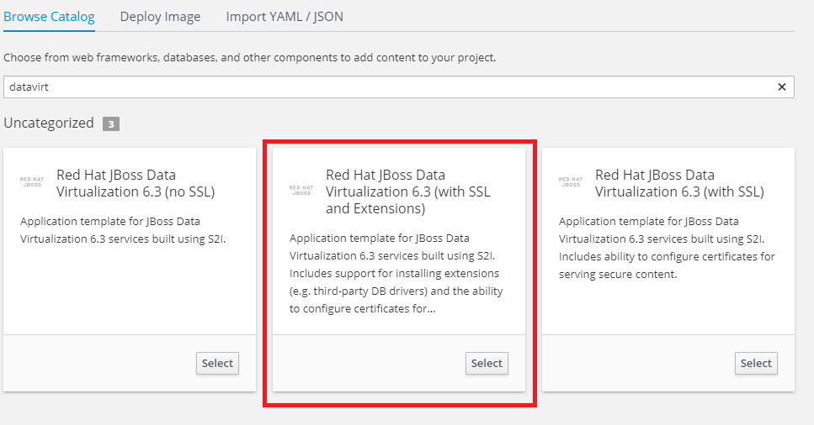

Used openshift-quickstarts-master template from Git and copied model xmi and vdb xml file to
C:\Users\143838\Desktop\openshift-quickstarts-master\datavirt\dynamicvdb-datafederation\app

- Uploaded datavirt in gitlab
- Used template for external data source as mentioned in following link

https://dzone.com/articles/jboss-data-virtualization-on-openshift-part-4-bringing-data-inside-the-paas
And Placed the vdb and make changes for external postgresql in the following folders
C:\Users\143838\Desktop\External_postgresql_template\External_postgres_template_2-master\extensions

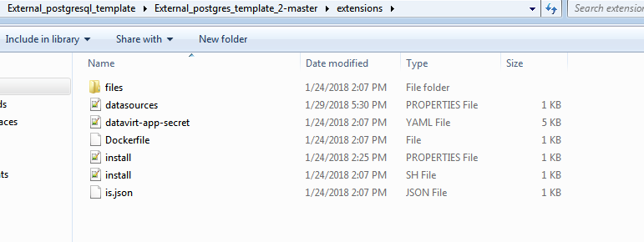

- Manually copied module.xml and PosgtreSQL deriver to module folder
- We can see the metadata
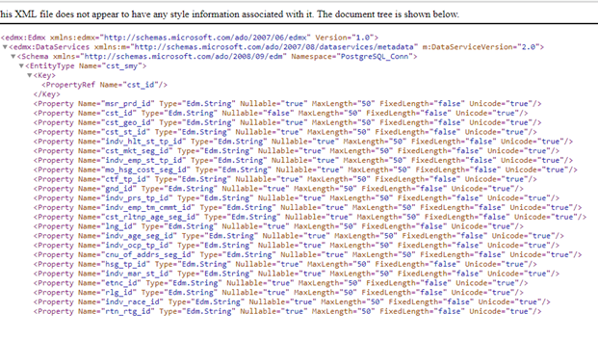

- We are unable to see the data for the VDB deployed in Openshift Pod
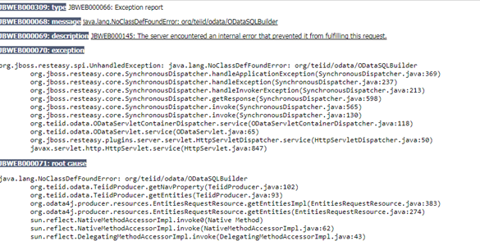
- Please find the log file attached herewith for your reference

